13. Dig the Data
Sort It Out With Microsoft EXCEL Part 1
(located on the remc.org/21things4students site)
Go to Dig the Data webpage, expand the green box (1) and select the SortItOut.xlsx file (2).
Important
Note: The songs shown in the screenshots in these directions may not be identical to yours. These are shown as examples.
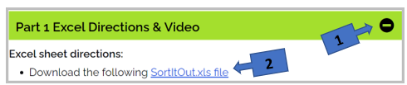
Download and save the spreadsheet to your computer or to your Drive Space (i.e., Microsoft OneDrive), name it Party Playlist, and add your initials at the end of the new filename. (Please Wait to add your own songs until after completing these sorting exercises.)

STEP 1
- Begin by Freezing the top row (the headers) to keep the headings from being sorted with the rest of the data
  - Go to the 1. View menu – Select 2. Freeze Panes – Then select 3. Freeze Top Row
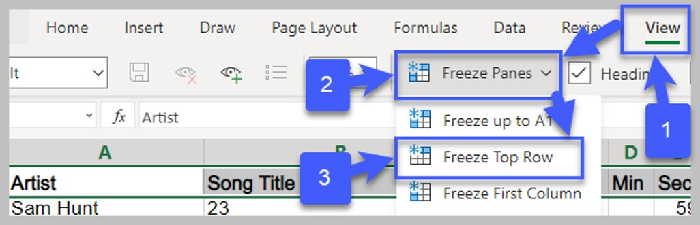

- Select All of the Data before doing a sort.
  - Go to all the data by clicking to the left of column A and above row 1 (result: the row becomes highlighted as shown below and the rest is shaded)
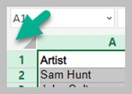

- Sort by Genre
  - Select the entire sheet by selecting the top left blank cell to the left of column A (result the entire sheet is now shaded)
  - Select the Data menu (b.)
  - Select Sort (c.)
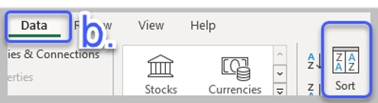
  - Then check My Data has Headers in the Sort window (d.)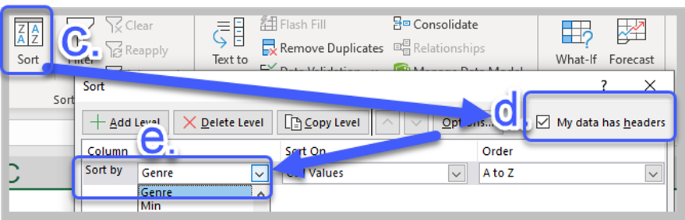
  - Use the Sort by dropdown list to choose Genre (e.).
Result: You should have a list sorted by genre listed together
Alternative, then Blues, etc. in column C.
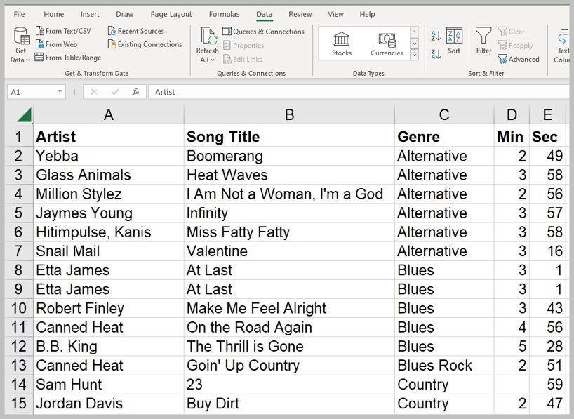

QUESTIONS:
- How many different Genre are in the list?
- Is your favorite type of music represented?
- Are there any duplicates? The next step will show you an easy way to locate and remove duplicates.
- Duplicates!!! - How to spot and remove duplicates:
  - Select the All the data set (top left cell to select all the data)
  - Select Data menu (b.)
  - Select Remove Duplicates (c)
  - Check My Data has a header row (d)
  - select OK (e)
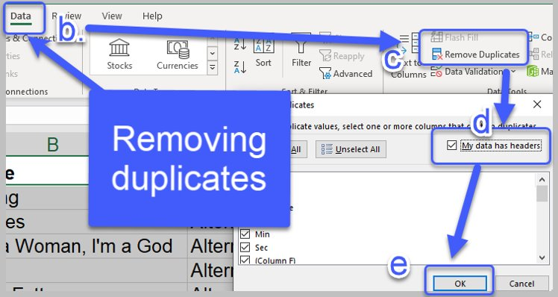

d. See the confirmation of how many duplicates were found and removed.
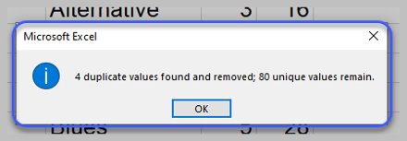
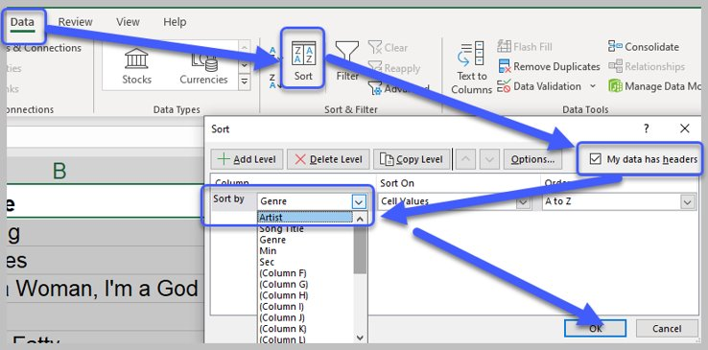
e. Now do another sort (Remember to select the entire data set: top left cell to select all the data) and do these actions:
    - Data menu
    - Sort
    - My data has headers
    - Sort by Artist
    - OK

QUESTIONS:
    - How many artists have more than one song in the collection?
    - How many artists have more than one song?

- Sort Again by Song Title
QUESTION: How many duplicate song titles are listed that are recorded by different artists?
COMING NEXT in Part 2: Create your own Playlist. Please check with your teacher about adding some (perhaps 10) of your own favorite songs to this list (remember to select appropriate song titles for your school setting and audience). Make sure to list them with the Artist/Group name, Song title, Genre, Minutes and Seconds like the rest of the data.
Congratulations on sorting the Song Database.

